HTML Computer Code Elements

📘 Definition
# Source: AI Source: Provided by: [Data Path: Persons Table -> ID Column: 1, Name_En Column: Motasem Essam] -> From: [ChatGPT] on [5/6/2026]
HTML provides special elements for displaying:
- computer code
- keyboard input
- program output
- variables
- preformatted text
These elements improve:
- readability
- semantics
- accessibility

🧠 Main Computer Code Elements
# Source: AI Source: Provided by: [Data Path: Persons Table -> ID Column: 1, Name_En Column: Motasem Essam] -> From: [ChatGPT] on [5/6/2026]
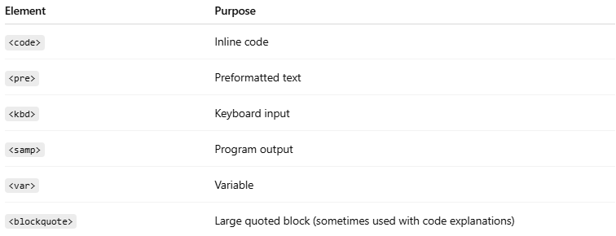
Element | Purpose
<code> | Inline code
<pre> | Preformatted text
<kbd> | Keyboard input
<samp> | Program output
<var> | Variable
<blockquote> | Large quoted block (sometimes used with code explanations)

1. 💻 <code> — Inline Code
# Source: AI Source: Provided by: [Data Path: Persons Table -> ID Column: 1, Name_En Column: Motasem Essam] -> From: [ChatGPT] on [5/6/2026]
📖 Description
Displays short inline code snippets.
Usually shown in:
- monospace font
💻 Example:
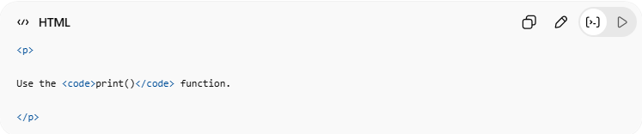
<p>
Use the <code>print()</code> function.
</p>
👉 Displays code inline

2. 📄 <pre> — Preformatted Text
# Source: AI Source: Provided by: [Data Path: Persons Table -> ID Column: 1, Name_En Column: Motasem Essam] -> From: [ChatGPT] on [5/6/2026]
📖 Description
Preserves:
- spaces
- line breaks
- formatting
Exactly as written.
💻 Example:
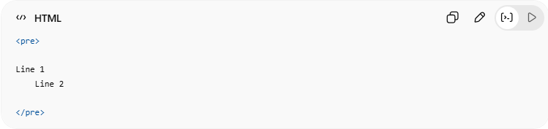
<pre>
Line 1
Line 2
</pre>
👉 Keeps original formatting

3. ⌨️ <kbd> — Keyboard Input
# Source: AI Source: Provided by: [Data Path: Persons Table -> ID Column: 1, Name_En Column: Motasem Essam] -> From: [ChatGPT] on [5/6/2026]
📖 Description
Represents keyboard keys or user input.
💻 Example:
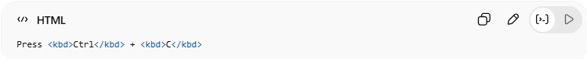
Press <kbd>Ctrl</kbd> + <kbd>C</kbd>
👉 Shows keyboard shortcuts

4. 🖥️ <samp> — Program Output
# Source: AI Source: Provided by: [Data Path: Persons Table -> ID Column: 1, Name_En Column: Motasem Essam] -> From: [ChatGPT] on [5/6/2026]
📖 Description
Represents output from a program or computer.
💻 Example:
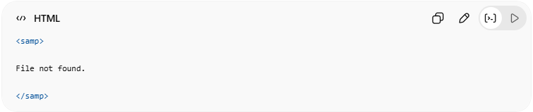
<samp>
File not found.
</samp>
👉 Displays program output

5. 🔤 <var> — Variable
# Source: AI Source: Provided by: [Data Path: Persons Table -> ID Column: 1, Name_En Column: Motasem Essam] -> From: [ChatGPT] on [5/6/2026]
📖 Description
Represents variables in programming or math.
💻 Example:
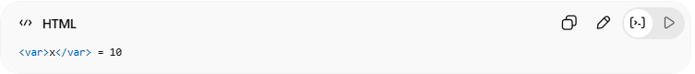
<var>x</var> = 10
👉 Displays variable names

🌐 Basic Example
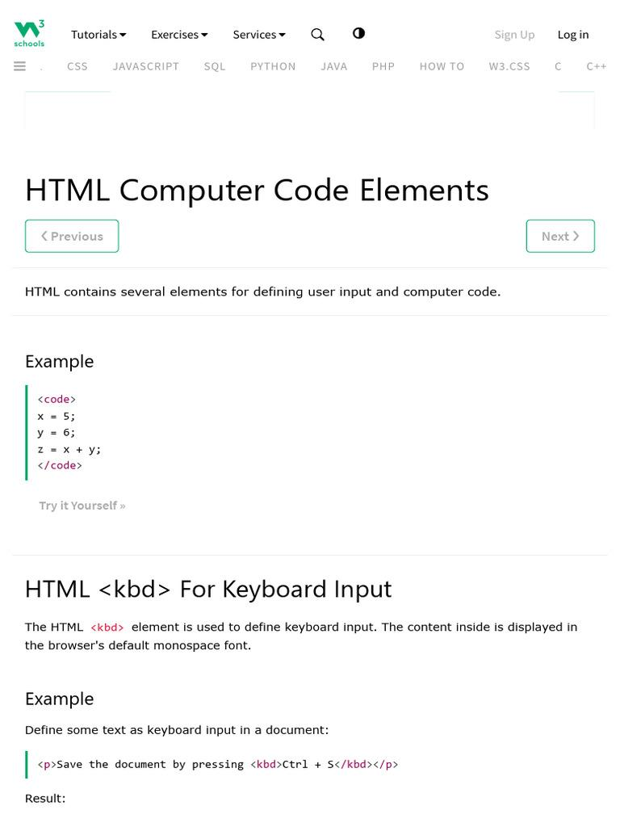
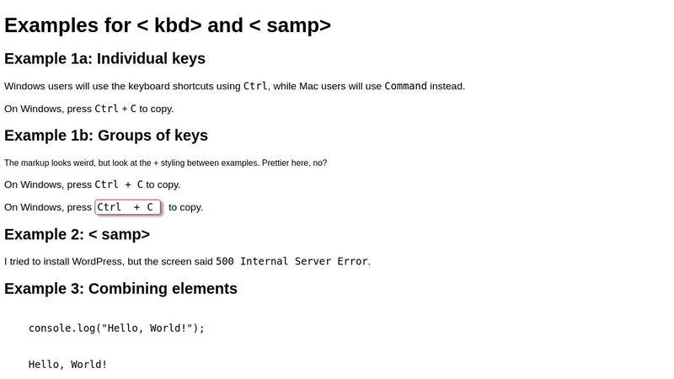
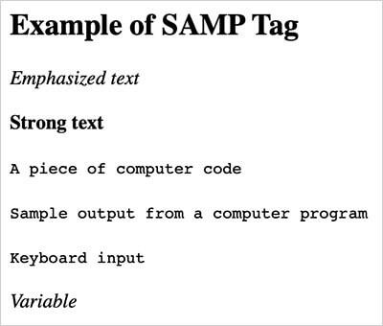
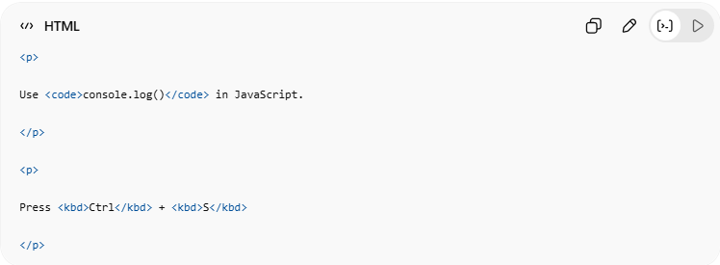
<p>
Use <code>console.log()</code> in JavaScript.
</p>
<p>
Press <kbd>Ctrl</kbd> + <kbd>S</kbd>
</p>

💻 Example

Full Example
# Source: AI Source: Provided by: [Data Path: Persons Table -> ID Column: 1, Name_En Column: Motasem Essam] -> From: [ChatGPT] on [5/6/2026]
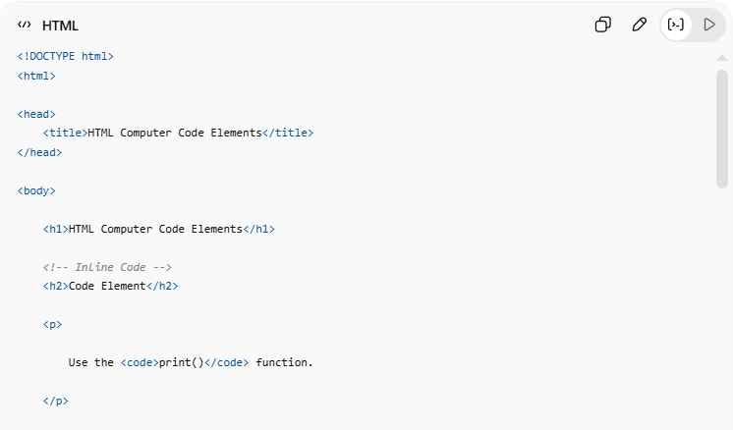
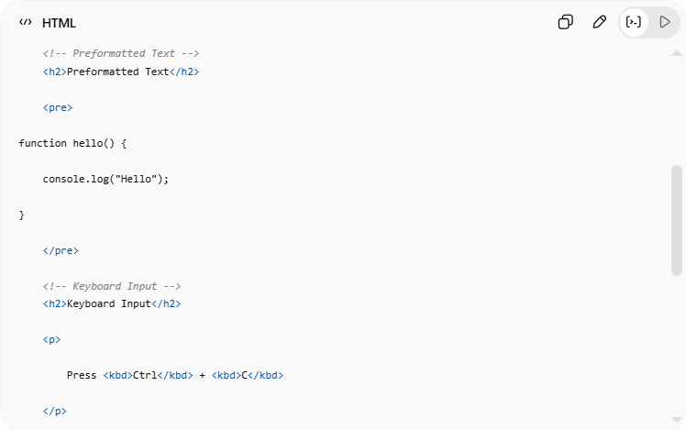
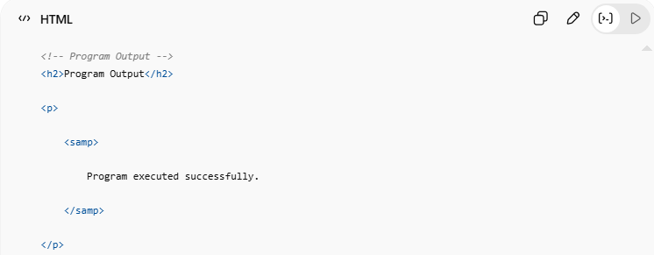
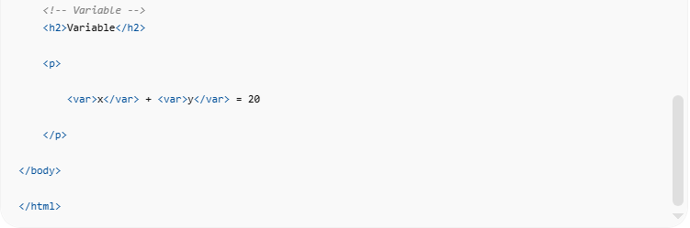

<!DOCTYPE html>
<html>
<head>
<title>HTML Computer Code Elements</title>
</head>
<body>
<h1>HTML Computer Code Elements</h1>
<!-- Inline Code -->
<h2>Code Element</h2>
<p>
Use the <code>print()</code> function.
</p>
<!-- Preformatted Text -->
<h2>Preformatted Text</h2>
<pre>
function hello() {
console.log("Hello");
}
</pre>
<!-- Keyboard Input -->
<h2>Keyboard Input</h2>
<p>
Press <kbd>Ctrl</kbd> + <kbd>C</kbd>
</p>
<!-- Program Output -->
<h2>Program Output</h2>
<p>
<samp>
Program executed successfully.
</samp>
</p>
<!-- Variable -->
<h2>Variable</h2>
<p>
<var>x</var> + <var>y</var> = 20
</p>
</body>
</html>

Real Example
# Source: ScreenShot Source: Provided by: [Persons Table -> ID Column: 1, Name_En Column: Motasem Essam] -> Tool: [Automation Table -> ID Column: 16, Name_En Column: Screen Capture] -> From [Operating System: Windows] on [5/6/2026]
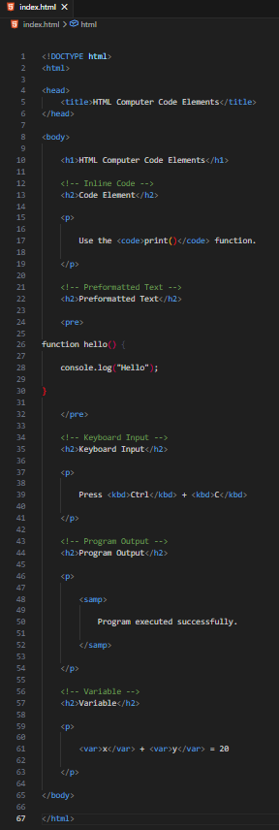
<!DOCTYPE html>
<html>

<head>
<title>HTML Computer Code Elements</title>
</head>

<body>

<h1>HTML Computer Code Elements</h1>

<!-- Inline Code -->
<h2>Code Element</h2>

<p>

Use the <code>print()</code> function.

</p>

<!-- Preformatted Text -->
<h2>Preformatted Text</h2>

<pre>

function hello() {

console.log("Hello");

}

</pre>

<!-- Keyboard Input -->
<h2>Keyboard Input</h2>

<p>

Press <kbd>Ctrl</kbd> + <kbd>C</kbd>

</p>

<!-- Program Output -->
<h2>Program Output</h2>

<p>

<samp>

Program executed successfully.

</samp>

</p>

<!-- Variable -->
<h2>Variable</h2>

<p>

<var>x</var> + <var>y</var> = 20

</p>

</body>

</html>
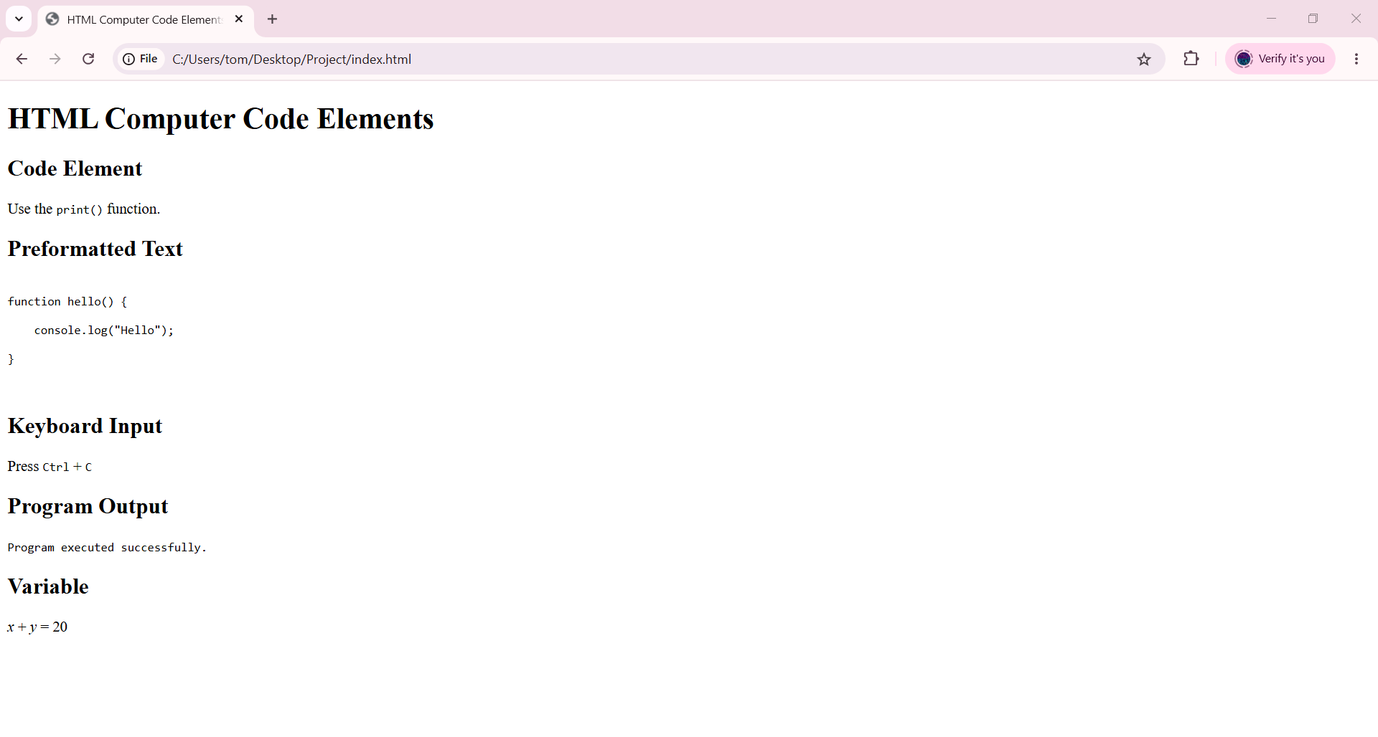

🧪 What You Can Test
# Source: AI Source: Provided by: [Data Path: Persons Table -> ID Column: 1, Name_En Column: Motasem Essam] -> From: [ChatGPT] on [5/6/2026]
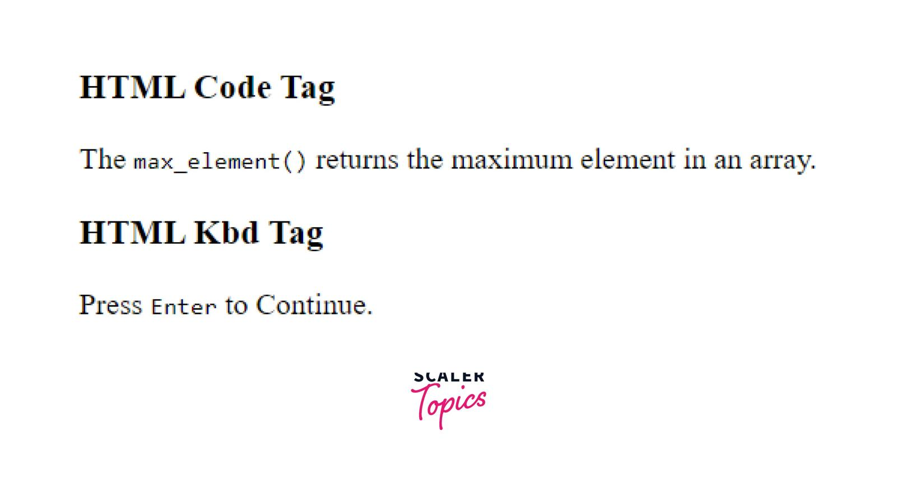


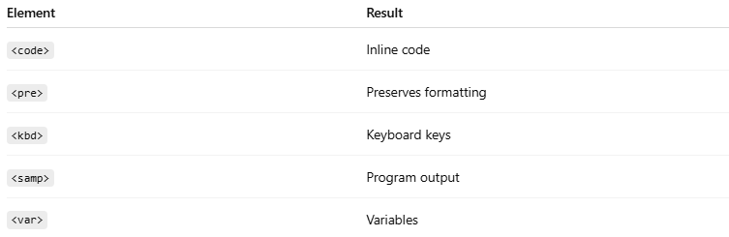
Element | Result
<code> | Inline code
<pre> | Preserves formatting
<kbd> | Keyboard keys
<samp> | Program output
<var> | Variables

⚠️ Important Notes

✅ <pre> preserves spaces and line breaks
# Source: AI Source: Provided by: [Data Path: Persons Table -> ID Column: 1, Name_En Column: Motasem Essam] -> From: [ChatGPT] on [5/6/2026]
👉 Useful for code blocks

✅ <code> is usually inline
# Source: AI Source: Provided by: [Data Path: Persons Table -> ID Column: 1, Name_En Column: Motasem Essam] -> From: [ChatGPT] on [5/6/2026]
👉 Small code snippets

✅ <kbd> improves accessibility
# Source: AI Source: Provided by: [Data Path: Persons Table -> ID Column: 1, Name_En Column: Motasem Essam] -> From: [ChatGPT] on [5/6/2026]
👉 Better keyboard instruction meaning

❌ Avoid using normal <p> for code
# Source: AI Source: Provided by: [Data Path: Persons Table -> ID Column: 1, Name_En Column: Motasem Essam] -> From: [ChatGPT] on [5/6/2026]
👉 Use semantic code elements instead

🚀 In short:
# Source: AI Source: Provided by: [Data Path: Persons Table -> ID Column: 1, Name_En Column: Motasem Essam] -> From: [ChatGPT] on [5/6/2026]
HTML computer code elements provide semantic tags for displaying code, keyboard input, variables, and program output clearly and correctly.

